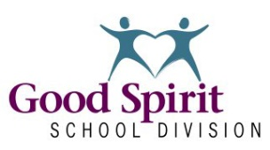

Insert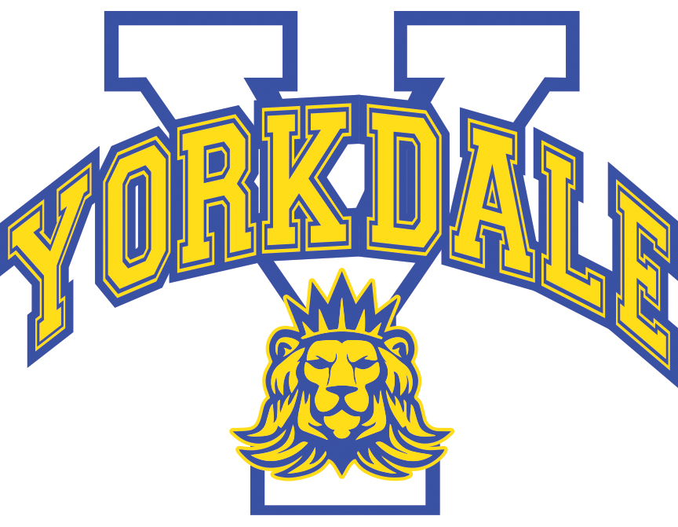 school logo here
School Level Plan
School: Yorkdale Central School School Year: 2021-2022
Component ONE – FOUNDATIONAL ITEMS
Division Motto, Mission, Vision, Values, & Aspirational Statements/Compelling Why | School Mission, Vision, Values, & Compelling Why
Motto – Students Come First  Mission – “Building Strong Foundations to Create Bright Futures”  Vision – “Learning Without Limits ... Achievement For All"  Values – Belonging, Respect, Responsibility, Learning, Nurturing, Perseverance and Diversity  High Quality Teaching and Learning  - Provincial curricula and related resources that are developmentally appropriate and culturally responsive.  - Place play based learning experiences that support a sense of personal competency, self-efficacy, and social responsibility; and,  - A wide range of opportunities to learn, practice, experience and demonstrate understanding, confidence, and motivation for a healthy and balance life.  Engagement of All Students, Families, and Communities  - Efforts are aligned to promote student, family, staff and community health and well-being.  - School Community Councils and First Nations Education organizations are involved in School Level Plans.  - School Leadership values cooperation, effective interpersonal communication and shared decision making.  - Schools, families, and communities engage in ongoing discussions and shared efforts to promote and support the health and well-being of staff, students, and the community; and,  - Reciprocal relationships share resources and services within the school and community.  Effective Policy  - Protocols for collaboration on policy development and related protocols practices for health and well-being.  - Ongoing evaluation and monitoring of needs and effectiveness of efforts to improve well-being.  - Promising practices that enhance and well-being; and,  - Clear practices, procedures, protocols and regulations regarding health and safety in children and youth (e.g., nutrition, anti-bullying, physical activity, pandemic planning, air quality).  Healthy, Sustainable Physical and Social Environments  - Access to and support for healthier options.  - A welcoming, caring, and inclusive environment.  - Healthy relationships among and between staff, students, and the community.  - Responsive and inclusive leadership of staff, students, and community.  - Relationships that influence and are influenced by families, cultural perspectives, and the community.  - Modern, responsible infrastructure to maintain and promote the highest levels of support for students, staff, families, and the community.  - Systems that ensure buildings, grounds, transportation, and technology are built and maintained not only to current standards, but that practices and procedures are in place to plan for a strong, vibrant future.  - Proactive, innovative approaches to sustain, support and grow Division facilities and systems.  - Efficiencies, both internally and externally, to ensure appropriate resources are targeted to our key areas including facilities, transportation, and technology.  - Strategies to use the school buildings and grounds, materials, equipment, and routes to and from the school to enhance well-being of staff, students, and the community; and,  - Informal role modelling, peer support, nurturing families, and safe communities. | YCS Motto: “Born to Lead”  YCS Mission: “In partnership with the community, Yorkdale Central School will provide a nurturing environment where each student can develop to one’s full potential in preparation for the future.”  YCS Vision: Yorkdale Central School is a center of educational excellence that…  - Develops, maintains and promotes academic, social, athletic leadership and cultural growth for all students.  - Creates an environment in which all are motivated to be active, involved, and enthusiastic learners.  - Promotes physical and emotional wellness.  - Encourages the support and participation of all its stakeholders.  YCS Values: Commitment. Community. Collaboration. Compassion. Courage.  Commitment: Making a commitment entails a promise, a course of action and sacrifice. We employ all of these in our pursuit of every student’s potential. We remain accountable in providing high-level opportunities for engagement and learning, and we support these efforts through high standards of teaching, continuous improvement and professional learning. Commitment is one of the values that underpin strong and mutually beneficial relationships. It is a strong indicator of a self-discipline, resilience, and persistence.  Community- We value professional integrity and respect, and these values provide a foundation for how we treat our students, parents, colleagues and stakeholders. This means assuming positive intent, practicing direct and supportive communication, maintaining confidentiality and honesty, and working toward mutual understanding. We will be honest, open, ethical and fair because stakeholders expect us to adhere to our word. Furthermore, we desire an environment where stakeholders may think big, have fun, and do good, while pursuing individual and shared passions.  Collaboration: We value the sense of connection between stakeholders in our community. We respect that our collective knowledge, talents, and efforts fuel our continual growth and successes. Collaboration is fostered through trust, which requires truth-telling, fulfilling promises and communicating celebrations and challenges. Collaboration promises shared accountability. When sustained over time, it also increases the overall expertise and efficiencies of stakeholders. Often, talent attracts new talent, which further benefits the community.  Compassion- In a culture of belonging, everyone matters, and therefore we will be present and connect with transparency, dignity and respect. We know it takes people with different ideas, strengths, interests, abilities and cultural backgrounds to succeed. Knowing this, we build relationships to foster a safe, healthy, and inclusive environment. We remain solution-minded in all issues. On a daily basis, we recognize that stakeholders do not care how much we know, or what we do, until they find out how much we care.  Courage: Courage is a highly valued virtue. Without courage, fear can erode our spirits, efforts and growth. Courageous individuals share a growth mindset, which promotes growth through determination and grit. We believe good work takes time to achieve. Furthermore, our community values those who persevere, challenge the status quo, and innovate, and courage supports the passions of these stakeholders who then engage, energize, and inspire others. True leadership is courageous, and it dares individuals to be make an impact and shape a better future for self and others.

Component TWO – ACTION PLAN
High Quality Teaching and Learning
Division Level | School Level
Division Outcomes | School Level Outcome &/or Work Plans  (Supports Sector and Division) | Evidence of Progress  (How Have You Done?)
By June 30, 2022, 27% more students will exit Kindergarten at appropriate development (green) than when entering Kindergarten. | By June 2022, the number of students exiting Kindergarten at the appropriate development (green) will remain at 95% or greater. | WORK PLAN:  By Sept 2021, Kindergarten teacher to prepare classroom with “play concept” while also adhering to safe COVID19 guidelines. (CS, MR, DN)  Through Sept to Nov 2021, Kindergarten students will be assessed and reported using the EYE-TA. Subsequent supports will be introduced through a more intensive pod setting where centres will be used to support EYE-TA concerns. (3 Adult/4 Centres) . (CS, MR, DN)  Through 2021-22, YCS and its Kindergarten teacher will continue to apply the ECKERS environment guidelines as a pilot school. Furthermore, there will be a number of parent engagement days beginning in October 2021. Utilize “sprints” to pursue phonological targets in student learning.  On a regular basis in 2021-22, Seesaw will be used as engagement tool with parent community. (CS, MR, DN)  In Sept 2021, a Kindergarten parent engagement & orientation will occur. (CS, MR, DN)  In Feb 2022 & March 2022 YCS may look to hold a Literacy Engagement Day then Numeracy Engagement for pre-schoolers (Ages 3-4). (DN)  In Feb 2022, YCS will complete, reflect & act upon Early Literacy Assessment.  In May 2022, K students not meeting success criteria in EYE-TA will be reassessed. (CS)  EVIDENCE:  GSSD Early Learning  EYE-TA Assessment Results  CLEVR- RtI Documentation  Responding to EYE Testing Results
By June 30, 2022, 90% of students will show one-years growth in their reading levels. | YCS: By June 30, 2022, >90% of Grade 1-6 students will achieve grade level standards using Fountas & Pinnell assessment.  YCS: By June 30, 2022, >70% of students receiving Levelled Literacy Intervention will complete intervention at grade level.  YCS: By June 30, 2022, of students not achieving Fountas & Pinnell standards, >95% will experience a growth of one year and/or meet their IIP/ROA literacy- related goal. | WORK PLAN:  Due to the interruption of COVID19 in 2019-21, YCS purchased Summer Reading Program resources. 15 students took part in the program. Resources will become a regular summer event February/March: look into new resources to supplement existing ones. (DN, LB, TD)  Commit to three benchmarking & staff reporting periods including Nov 2021, March 2022 and May 2022. Subsequent guided reading practices & interventions. (ALL)  Continue to use Rime Magic in primary classrooms and for intervention. (DN, LB, TD, Support)  Commit to LLI Interventions September 13, 2021. LLI Leadership Team will respond promptly to patterns of achievement. (DN, LB, TD)  SST’s will receive Haggerty training and discuss possibility of use and implementation.  Explore the RISE intervention. D. Lorenzo and S. Kemp are both familiar with the resource. They may do a demo for staff. Susan Robertson could also be a resource. (DN, LB, TD)  In January 2022, One School One Book event to be facilitated. Dragon In a Bag, by Zetta Elliot, is the title and copies have already arrived. Committee will meet and plan the event which culminates with a family night in whatever form Covid restrictions allow. Prepare packages for home January 2022 (TD, LB, DN)  EVIDENCE:  Reading Benchmarks, Outcome- Based Reporting, GSSD LOOK FORS, Artifacts of Learning Outcome Progress. Evidence of Professional Development. RTI Timetable and Record Sheets. Student Services timetables & reports.  YCS Facebook, Twitter & Webpage will reflect literacy events occurring within YCS  GSSD indicators of Responsive Teaching  GSSD ELA Curriculum, Assessment & Instruction  GSSD Literacy Link  Word Study  Levelled Literacy Intervention  SASK READS  SASK READS for Administrators  Rime Magic  GSSD Data Warehouse
By June 30, 2022, there will be 2% more students writing at or above grade level in Grades 4, 7, & 9 compared to the June 2019 data. | YCS: By June 30, 2022, 75% of Grade 1-8 students will achieve grade level standards in writing achievement, according to the holistic rubric. | WORK PLAN:  Through 2021-22, Grades 4 & 7 to work closely with GSSD leaders & colleagues with instruction & reporting to the province. Other grades also to partake in instructional and assessment practices including development of instructional walls by Oct 2021 and writing portfolios by Nov 2021. (DN, JH, EC, EN, SK GE, ALL)  By Oct 2021, staff members provided with possible templates for writing conferences. (DN, ALL)  Commit to a half day on January 31 2022 to work with grade alike partner to benchmark writing and exemplars. (DN, Committee)  Organization of a “Writing Wall” bulletin board by library. The writing showcase will be done in the Spring giving the younger grades time to learn their writing. For this year, we will not be showcasing their levels. Each Grade will be given a week to showcase any writing that made them or their student proud. Teachers can showcase as much work as they like in any style. This can also be shared on social media since the levels won’t be shown. (Committee)  EVIDENCE:  Data will be collected in June, 2022 for writing goals. Teachers use holistic rubrics and provide results to DN.  Professional Development. RTI Timetable and Record Sheets. GSSD Action Plan. Student Services timetables & reports. YCS Facebook, Twitter & Webpage will reflect writing events occurring within YCS  Writing Continuum & Rubrics  GSSD Writer In Residence  GSSD indicators of Responsive Teaching  GSSD ELA Curriculum, Assessment & Instruction  GSSD Literacy Link  Word Study  GSSD Data Warehouse
By June 30, 2022, there will be 2% more Grades 2, 5, & 8 students at or above grade level in math compared to the June 2019 data. | YCS: By June 30, 2022, at least 70% of Grade 1-8 students will be at or above grade level in math using the math analytical rubrics. Grades 2, 5, & 8 will be reported to the province.  YCS: By June 30, 2022, >90% of Grade K-4 students will achieve grade level standards using achievement data from the YCS outcome-based report cards.  YCS: By June 30, 2022, >90% of Grade K-4 students will achieve grade level standards using achievement data from the YCS outcome-based report cards. | WORK PLAN:  By Sept 2022, teachers will use Knowledgehook resources.  By Oct 2022, students will be accessing benefits of Knowledgehook as part of their regular math classes.  By Oct 2022, Math Committee will establish consistency in Math Screener implementation through the development of a written document. Entry Screeners to be completed by students by Sept 17th, 2021.  Subsequent review to determine students to be targeted for classroom & interventionist support. (30 minutes periods over a four-week block)  By Oct 2022, priority areas for scheduling of Math Intervention & support will be determined. This will be reviewed at Nov 2021, Jan 2022 (new schedule CV), March 2022.  By Nov 2021, recommendations would be made to administration for mathematical resources.  By mid-Oct 2021, Math instructional wall to be erected & maintained in all classrooms.  In April 2022, a math engagement activity will occur both in home and/or at school.  By May 2022, Mid-Year Screener (B) will be completed by all grades and entered into CLEVR for tracking.  In June 2022, final assessments & reporting on student progress.  EVIDENCE  Holistic Math Rubrics, GSSD Math Screeners, GSSD Math Rubrics, SK Common Math Assessments  Mathology  Knowledgehook  All Ministry Created Math  GSSD MATH Curriculum, Assessment & Instruction  GSSD Links & Resources  Math Common Assessments  Math K-9 Screeners  Math Screener Spreadsheet  GSSD Data Warehouse  Numbers Talk Resource (Mental Math & Computation)  Saskatchewan Mathematics Teachers Society  Developing Mathematical Thinking Institute (DMTI)  Math intervention resources
By June 30, 2022, the number of students in Grades 4 to 12 reporting high levels of anxiety will reduce by 2% from spring 2021 data. | By June of 2022, the number of students reporting high levels of anxiety will reduce by 2%.  By June 2022, 85% of students will report that they have staff advocacy to provide encouragement and support as required. This will be reflected in the OurSchool and SOS-Q surveys. | WORK PLAN:  We continue to work with the Return to School document from GSSD. Covid protocols have unfortunately become more familiar to staff and students. We continue to adapt our school systems to the document. (DN, TB, ALL)  By Oct 2020, Mentorship & Buddy Reading will be placed to begin in accordance to COVID19 guidelines. “Girl Empowerment,” Safety Patrol and SRC will begin when possible. (DN, BB, RS, RK, EC, ALL)  Through 2021-22, support & volunteerism will continue for both the breakfast & lunch programs. New strategies.  Beyond the Hurt leaders will facilitate a school review by location. (TB, LB) Staff supervision habits to reflect data. To be reviewed in February 2022. (DN, TB)  Administer & Review results of student surveys, including OurSchool in May 2021. Child Study Team & Staff to determine interventions including Teen Boost, counselling, outside agencies, etc.  (DN, Grades 4-8)  EVIDENCE:  Return to School Document  COVID19 Training  Staff- Student Connecting List  SRC & Mentorship Members  Girl Empowerment Membership  Sharing in Social Media  Child Study Team Minutes  SOS-Q (past)  OurSchool
By June 30, 2022, the three-year graduation rate will increase by 2% from the June 2021 data. | Commitment to literacy, numeracy, attendance and student wellness goals in other areas of 2021-22 Learning Improvement Plan | EVIDENCE:  As planned & required, YCS staff will take part in transitional meetings where students are entering & exiting the school system, including Grade 8 students moving to the YRHS setting. (DN, LB, TD, BB, RS, EC)  Through 2021-22, the Child Study Team and classroom teachers will review Grade 7/8 F&P Fall Assessments (Yellow/Red) and commit/support to discussion of independent reading and conferencing within the classrooms. (DN, TB, LB, TT, BB, ALL)  Efforts to be reflected in GSSD graduation data.
By June 30, 2022, the five-year graduation rate will increase by 2% from the June 2021 data. | See above. | See above.
By June 30, 2022, students in Grades 4 to 12 will report a 2% increase in student intellectual engagement from spring 2021 data. | YCS: By June 30, 2022, YCS students in grade 4 to 12 will report at least a 3% increase in student intellectual engagement. | WORK PLAN:  Through 2021-22, implement engaging content within curriculum learning. Teachers will initiate contact with students’ homes and Child Study Team with signs of disengagement. (ALL)  Administration will commit to a bi-monthly review of attendance data, and teachers will inform of attendance concerns as needed. Interventions will be immediate & documented via MSS & CLEVR. (DN, CE, LB, TB, ALL)  In Nov 2021, review of engagement data reflected in the SOS-Q and Our School data collection. Note that SOSQ only happens every 2 years. (Child Study)  Through 2021-22, monitor student use & assigned lists to Homework Room. (DN)  EVIDENCE:  SOS-Q  OurSchool  Child Study Team Minutes  Homework Room Document
By June 30, 2022, GSSD will demonstrate a commitment to provide professional development and training to its staff based on the four Aspirational Statements.

Engagement of All Students, Families and Communities
Division Level | School Level
Division Outcomes | School Level Outcome &/or Work Plans  (Supports Sector and Division) | Evidence of Progress  (How Have You Done?)
By June 30, 2022, all students will achieve a 2% increase in student attendance based on the June 2021 data. | YCS: By June 30, 2022, 90% of all YCS students in Kindergarten to Grade 8 will achieve at least a 90% attendance (green). Students who failed to achieve this level in 2020-21 will increase their attendance rate by >5%.  YCS In June 2021, YCS will look to analyze data in strands, including school enrollment versus remote learning. | WORK PLAN:  Beginning of the School Year connections, including those students considered at-risk in the previous year. Review previous year data. (ALL, DN, LB, TD, BB)  Through 2021-22, positive attendance habits will be shared periodically through social media and emailed announcements. Through 2021-22, monthly monitoring by classroom teachers and administrations. Record required interventions through CLEVR. (DN, CE, LB, TD, ALL)  All year, attendance awareness efforts will be included in YCS FLASH, which will be shared weekly. (DN)  By October 2021 designation of healthy relationships with school adults draft sheet. These relationships will be fostered all year. (JB, EN)  EVIDENCE:  GSSD Data Warehouse  Editions of YCS Flash  Documentation within Edsby and CLEVR  Teacher- Student Lists from School Culture Committee
By June 30, 2022, GSSD will increase our organization’s cultural competencies through division-wide processes and professional learning that grow our collective understanding about Indigenous identity, histories, worldview, and systemic barriers. | By June 30, 2022, YCS will increase our organization’s cultural competencies through division-wide processes and professional learning that grow our collective understanding about culture diversity and truth & reconciliation.  By October 2020, all school staff had completed the “4 Seasons of Reconciliation” course.  By March 2020, all School Community Council Members had completed the “4 Seasons of Reconciliation” course.  This important work will proceed with the support of GSSD Indigenous Student Success Coordinators. | WORK PLAN  Development of Portal Folder for the organization of instructional supports for Reconciliation by September 2021 (SB, DN)  YCS Participation in Orange Shirt Day 2021. YCS was pleased to have Zoom presentations for our classes on September 30. Also, many classes and individuals are doing the Reconciliation Challenge to be submitted to GSSD Indigenous Success Consultants by Oct. 15, 2021. (ALL)  Reconciliation activities will be echoed throughout the year in classes, activities and events throughout the school. Reminders in the Flash and Staff Meetings. (DN, ALL)  Through 2021-22 continued reconciliation awareness in the YCS Flash. (DN)  By Oct 2020, all YCS staff members had completed the “4 Seasons of Reconciliation” course. (ALL) This has been completed by SCC Members.  YCS to continue indigenous art (beading, quilling ,etc) activities in Grades 5/8 (BB, EC)  By February 2022, YCS will secure services to facilitate “hoop dancing” within its physical education classes. (DN, JB, EN, GE, SK)  With the re-purposing of front display cases, one case will be dedicated to a display related to Reconciliation. This will be completed prior to National Aboriginal Day June 21, 2022. (Committee)  CSCH Committee work will focus on creating a welcoming physical building for not only Indigenous students and families, but also all members of our diverse student body and school community. (ALL)  EVIDENCE  YCS Portal Staff Room  4 Seasons of Reconciliation  Record of Budget Expenditures  Use of Aboriginal Workers within the classrooms  Welcoming building
By June 30, 2022, GSSD will demonstrate a commitment to the establishment of new and reaffirmed partnerships. | YCS will work with GSSD to support and actualize within the YCS school community.
By June 30, 2022, GSSD will actualize an Early Years Engagement Network to enhance educational opportunities for early years students. | YCS will work with GSSD to support and actualize within the YCS school community.
By June 30, 2022, GSSD will establish a First Nations, Métis, and Inuit Advisory Council to enhance educational opportunities for Indigenous students. | YCS will work with GSSD to support and actualize within the YCS school community.

Effective Policy and Procedures
Division Level | School Level
Division Outcomes | School Level Outcome &/or Work Plans  (Supports Sector and Division) | Evidence of Progress  (How Have You Done?)
By June 30, 2022, each functional area within GSSD will demonstrate improvement in services through the development, review, and revision of administrative procedures that reduce barriers and enhance student success. | YCS will work with GSSD to support and actualize within the YCS school community.
By June 30, 2022, each functional area within GSSD will demonstrate improvement in services through the development, review, and revisions of processes that reduce barriers and enhance student success. | YCS will work with GSSD to support and actualize within the YCS school community.
By June 30, 2022, GSSD will implement systemic and transparent approaches to find efficiencies and increase value for money allowing the Division to respond to the challenges of student and staff needs. | YCS will work with GSSD to support and actualize within the YCS school community.

Healthy, Sustainable Physical and Social Environments
Division Level | School Level
Division Outcomes | School Level Outcome &/or Work Plans  (Supports Sector and Division) | Evidence of Progress  (How Have You Done?)
By June 30, 2022, students will report feeling welcomed, included and feel a sense of belonging and caring at school. | YCS is working through the CSCH plan developed at the Division level and will add to the Work Plans and Evidence in the LIP. The 4 Pillars of CSCH are:  - High quality teaching and learning  - Effective Policy and Procedures  - Engagement of all students, families and communities  - Healthy and sustainable physical and social environments  This will be completed with the support of GSSD Indigenous Student Success Consultants and the GSSD CSCH initiative. | Showcase at front entrance of school will be created reflecting Indigenous art, culture and history including local connections to Yorkdale Central School. Will be in place by January, 2022. (GE, EN, DN)  Displaying posters with Indigenous language around the school. (EC, LB)  Create a pamphlet which can be distributed to new families as well as published on our school website with information about our school and how students will find a place at Yorkdale Central School. (Committee of DN, LB, TB, VH, SCC member, SRC member, and a teacher to be determined.)  Explore the development of a 4-House spirit system within the school. Students earn points for participating in Spirit Days, Sports Teams, Intramurals, Clubs, etc. This is a big project, so the committee will start slow and see if there is merit in the idea. Initial meeting by December 15, 2021 (DN, LB, TB, SRC members, JB, EN, GE, SK)  Inclusion of Indigenous content and culture in classroom and instruction. Teachers will use a variety of resources to enhance the understanding of indigenous topics in school. Such resources are Indigenous Guest Speakers provided by GSSD, Grade appropriate teaching resources provided by Indigenous Student Success Coaches J Armstrong and C Delorme as well as Truth and Reconciliation resources. Information provided to teachers regularly in Friday Flash. (DN, LB, TB, Staff)  New students, at-risk students and behaviour-students are connected with one or two staff members in order to form healthy, positive relationships. Strategically connected with appropriate playground supervisor or classroom teacher. (DN, LB, TB, Climate Committee)
By June 30, 2022, staff will report feeling welcomed, included and feel a sense of belonging and caring at work. | YCS is working through the CSCH plan developed at the Division level and will add to the Work Plans and Evidence in the LIP. The 4 Pillars of CSCH are:  - High quality teaching and learning  - Effective Policy and Procedures  - Engagement of all students, families and communities  - Healthy and sustainable physical and social environments  This will be completed with the support of GSSD Indigenous Student Success Consultants and the GSSD CSCH initiative.  Create a physical environment at Yorkdale welcoming people from all cultures including Indigenous cultures | Showcase at front entrance of school will be created reflecting Indigenous art, culture and history including local connections to Yorkdale Central School. Will be in place by January, 2022. (GE, EN, DN)  Displaying posters with Indigenous language around the school. (EC, LB)  Create a pamphlet which can be distributed to new families as well as published on our school website with information about our school and how students will find a place at Yorkdale Central School. (Committee of DN, LB, TB, VH, SCC member, SRC member, and a teacher to be determined.)  Ensuring all staff are included in communication, staff meetings, etc.  Continue to encourage Grade-alike collegial teams. (DN, TB, LB)  Outdoor school keys were provided to all EA staff. (DN)
By June 30, 2022, students will develop mental fitness (state of well-being and having a positive sense of how we feel, think, and act) to identify emotions and access supports. | YCS is working through the CSCH plan developed at the Division level and will add to the Work Plans and Evidence in the LIP. The 4 Pillars of CSCH are:  - High quality teaching and learning  - Effective Policy and Procedures  - Engagement of all students, families and communities  - Healthy and sustainable physical and social environments  This will be completed with the support of GSSD Indigenous Student Success Consultants and the GSSD CSCH initiative.  Create a physical environment at Yorkdale welcoming people from all cultures including Indigenous cultures | School Counsellor will share information with students and families about the availability of school counselling as well as connections to outside agencies of support by going into classrooms and sending information home with students. (BB)  Peer-Tutoring (non-Covid Time) – Grade 6 to 8 students are paired with younger students (Grade 1 to 3 typically). Older students support academic programming. (Student Support Team and SRC)  Mentorship (non-Covid Time) – younger students are paired with older students to engage in fun and positive activities over lunch. (BB, EC, TD)  Reading Buddies (non-Covid times) – older classrooms pair up with younger classrooms to read books together during instructional time. Each teacher organizes this with a colleague.  Playground rules and expections around playground supervision evolve as per changing needs of students and groups. With Covid, supervision teams coordinate student re-entry after recess, outdoor sweep, mask and sanitizing protocols. (DN, LB, TB, All Staff)  Kindness Challenge - SRC students are developing a kindness Challenge which encourages all students to be kind and positive citizens in our school – living the Code. This is in conjunction with a “Take What You Need – Give What You Can’ Bulletin Board project spearheaded by Grade 8 students during RTI. (DN, LB, TB, EC, RS, SRC)  40 Developmental Assets will be brought into Yorkdale School throughout the year. Darran Teneycke (SIGN) plans to come in, make connections with students by donating sub time, and then conduct a survey of students Grades 6, 7 and 8, in the Spring. This will provide valuable data to support students who may not have a healthy number of assets. (DN, Darran Teneycke, BB, LB, TB)
By June 30, 2022, staff will develop mental fitness (state of well-being and having a positive sense of how we feel, think, and act) to identify emotions and access supports. | YCS is working through the CSCH plan developed at the Division level and will add to the Work Plans and Evidence in the LIP. The 4 Pillars of CSCH are:  - High quality teaching and learning  - Effective Policy and Procedures  - Engagement of all students, families and communities  - Healthy and sustainable physical and social environments  This will be completed with the support of GSSD Indigenous Student Success Consultants and the GSSD CSCH initiative.  Create a physical environment at Yorkdale welcoming people from all cultures including Indigenous cultures | YCS Social Committee and YCS Sunshine Committee work to include and support all staff.  5 staff social events throughout the year. The first being the Beginning of the year staff scavenger car rally (EN, Social Committee)
By June 30, 2022, students will receive timely and responsive evidence-based prevention and intervention services at school. | YCS is working through the CSCH plan developed at the Division level and will add to the Work Plans and Evidence in the LIP. The 4 Pillars of CSCH are:  - High quality teaching and learning  - Effective Policy and Procedures  - Engagement of all students, families and communities  - Healthy and sustainable physical and social environments  This will be completed with the support of GSSD Indigenous Student Success Consultants and the GSSD CSCH initiative.  Create a physical environment at Yorkdale welcoming people from all cultures including Indigenous cultures | School Counsellor will share information with students and families about the availability of school counselling as well as connections to outside agencies of support by going into classrooms and sending information home with students. (BB, DN, LB, TB)
By June 30, 2022, students and families will report that they know where to turn for more intensive support when needed. | Continue to respond to the needs of students and families as they are self-reported, reported by peers and reported by staff. | School Counsellor will share information with students and families about the availability of school counselling as well as connections to outside agencies of support by going into classrooms and sending information home with students. (BB, DN, LB, TB)
By June 30, 2022, GSSD will enhance the physical facilities occupied by students and staff to ensure health and well-being. | Continue to monitor the physical state of the building and classrooms and respond immediately to areas of concern. | Prioritizing Asset Planner entries to make sure high priority jobs get the attention they need. (DN, TB, LB, KB, RH, KG)  School Zone Safety – purchased green pylons, bus loading zone is currently under review, announcements to parents about driving safely, increased adult vigilance of drivers, safety patrollers after school, investigating cost to install radar speed signs going both directions in front of school. (DN, Ryan Hall @ GSSD, SCC)  First touchless water fill station to be installed by November 5, 2021 in the K/1 hallway. (DN, Facilities)  Increased custodial services in response to Covid. (Facilities)
By June 30, 2022, all high schools will have established alliances for gender and sexual diversity. | While YCS is not a high school, we are responding to the needs of students who are gender diverse. | School counsellor will create a group which can transition into the Gender and Sexual Diversity Alliance at the High School Level. (DN, BB)

Component THREE - THE REVIEW PLAN
Three times per year, the school team should unpack their LIP. Emphasis should be placed on results. The following questions may be used as prompts for discussion.
- What is on and off target?
- What do we need to adapt in our plan?
- What can we do to be more effective as a team?
- What can I do to be a more effective team member?

Component FOUR - THE COMMUNICATION PLAN
How will the plan and progress be communicated to the school community? Note, a copy of the signed School Level Plan should be posted on the school website.

In-School Administrator(s) Signature | Date
School Community Council Chairperson Signature | Date

Learning Improvement Plan Resources
Strategic Plan Cascade
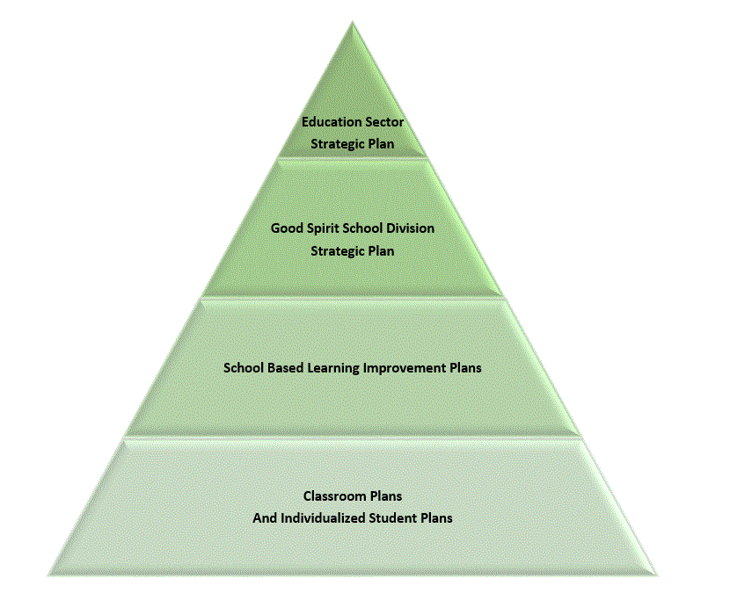

GSSD Student Success Framework
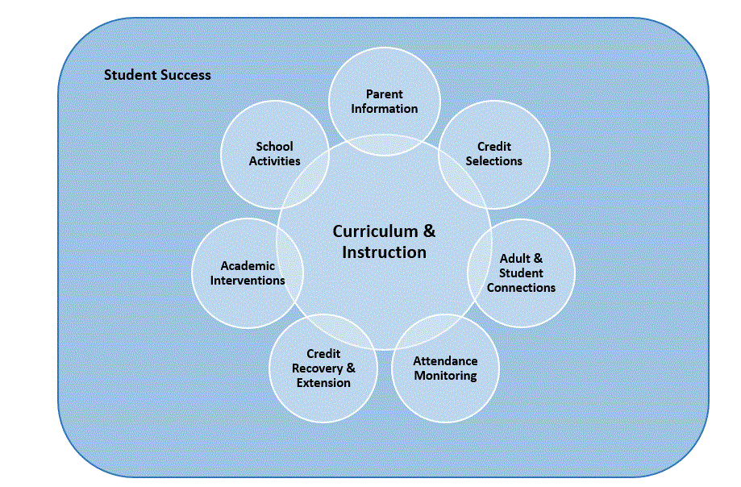
GSSD Attendance Pyramid of Interventions
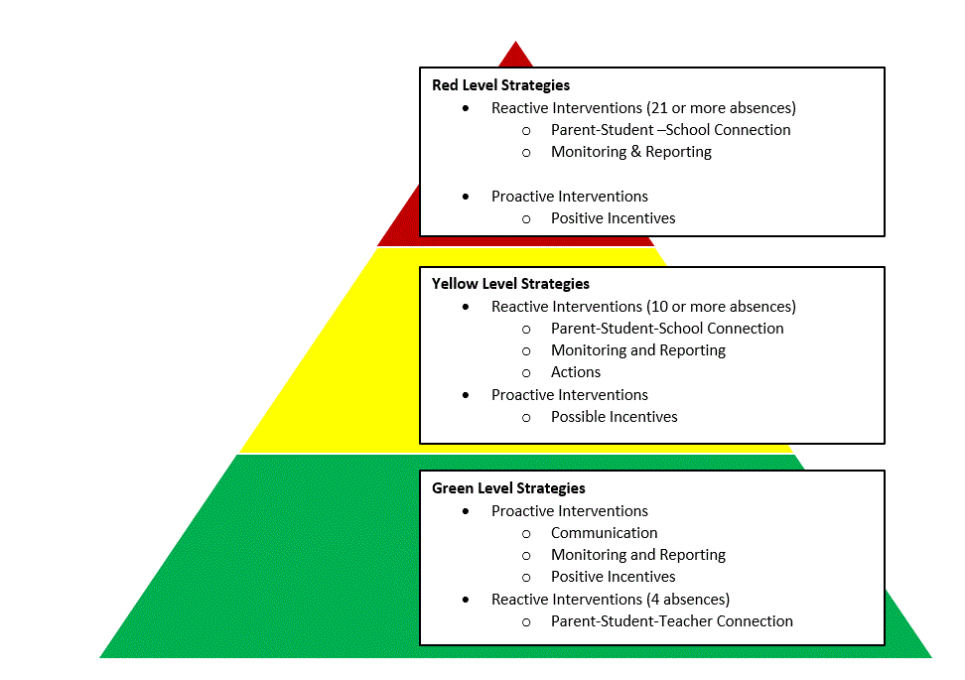
GSSD Academic Pyramid of Interventions
